Week 2 Assignment

**Answer:** Campaign 10

Data visualization charts that helped us analyze data and consequently choose to discontinue campaign 10. We believe that, while campaign 10 was the cheapest to produce; it is the least cost-effective, has the lowest impressions/reach, and had the fewest clicks.

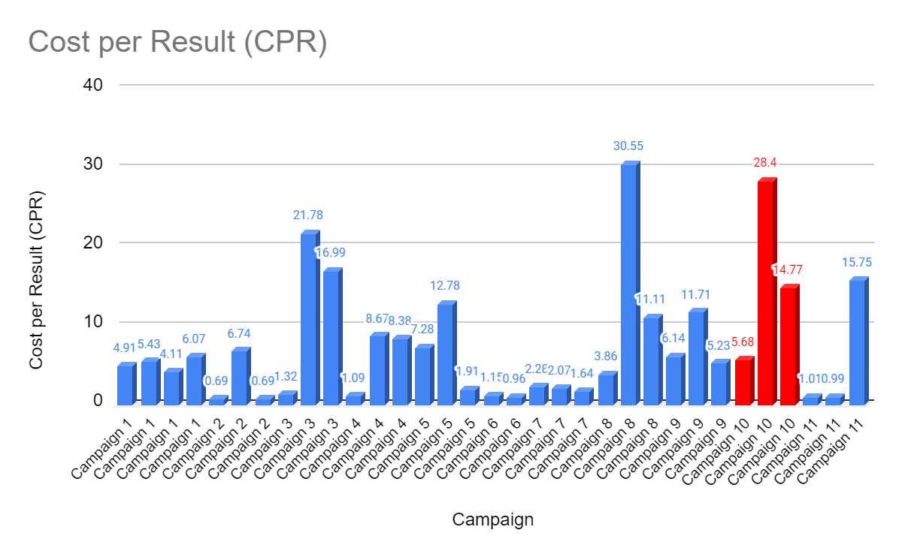

Bar graph showing that campaign 10 has the highest average cost per result.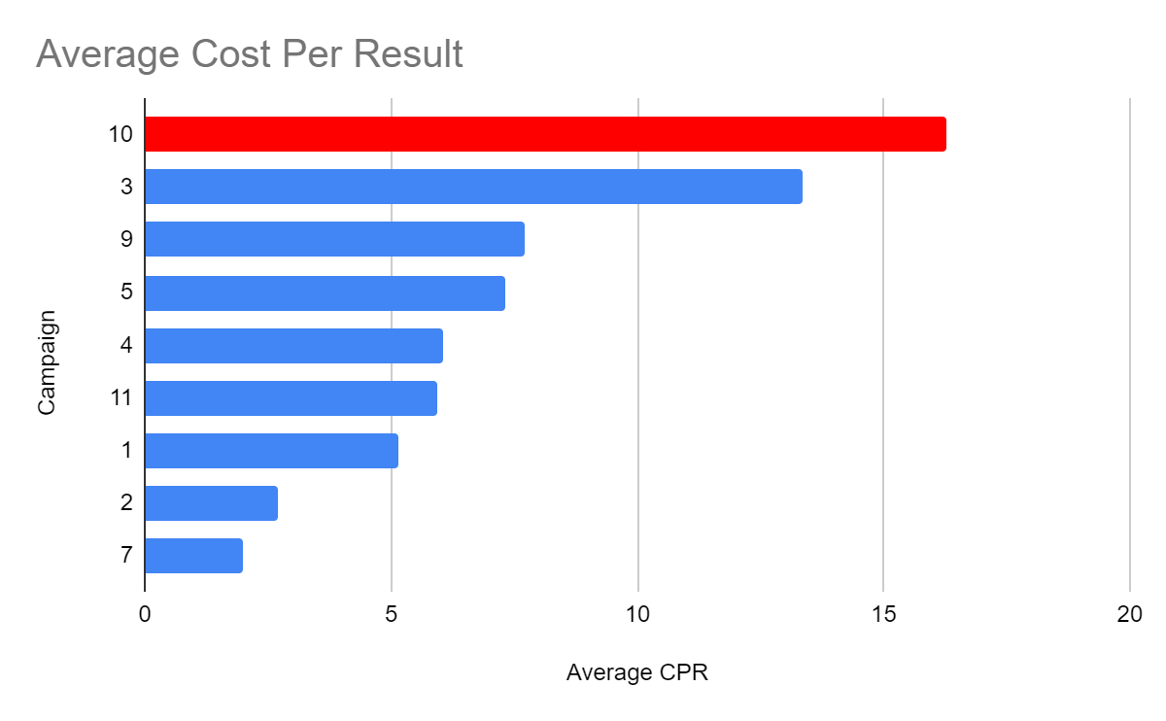

Bar graph showing campaign 10 has the highest average cost per result.

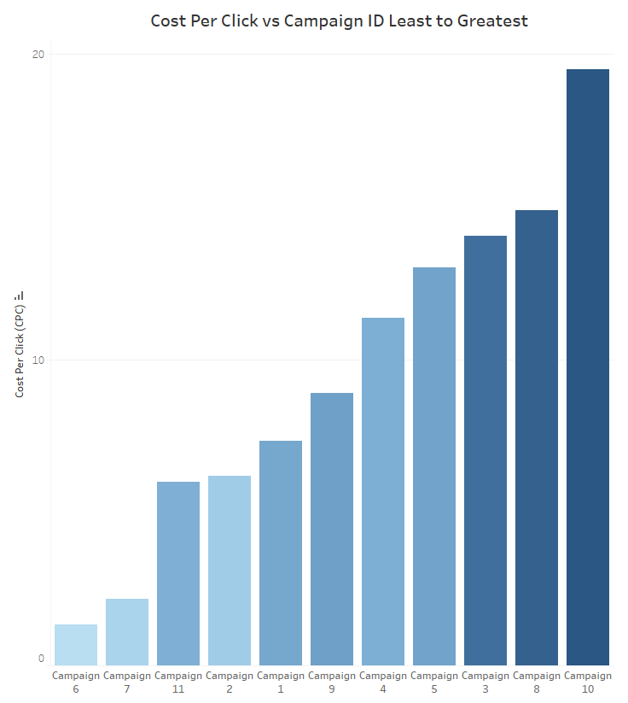

Bar graph showing campaign 10 has the highest cost per click ratio

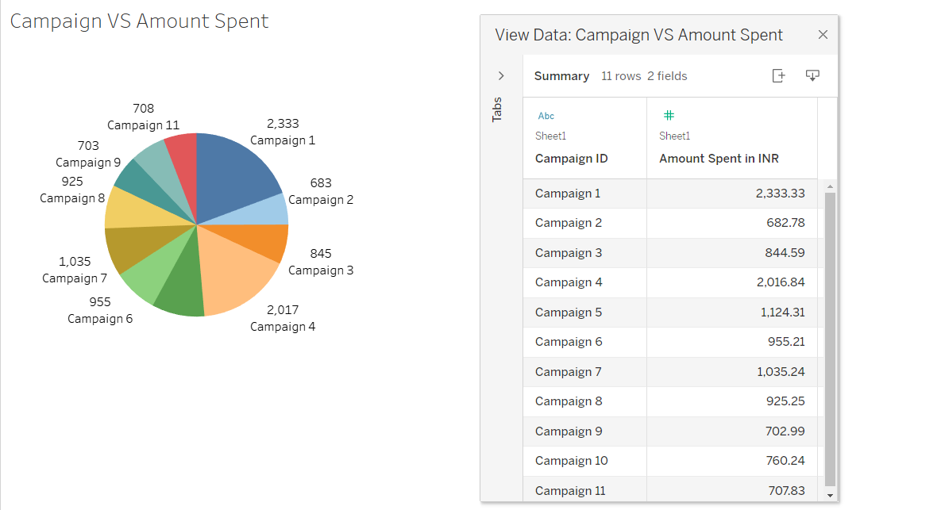

Pie Chart describing the share of the amount spent on each of the campaigns. Over here Campaign 10 has a comparatively low amount spent value compared to other campaigns

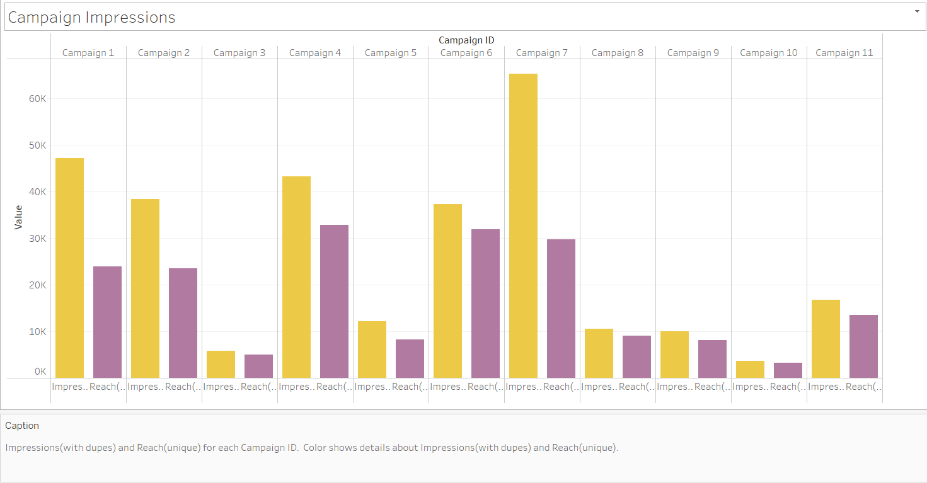

Multi-Bar graphs describing the impressions and reach count of each campaigns. Over Here the impressions and reach count of campaign 10 is the least compared to others.

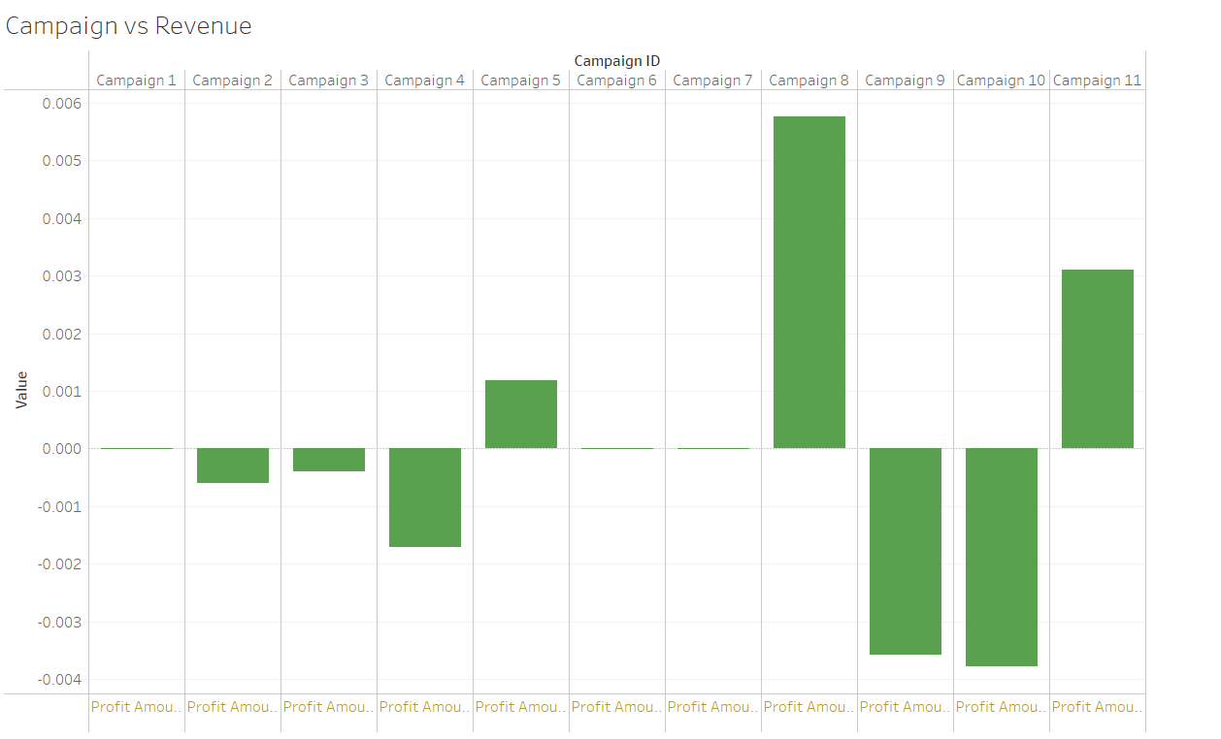

Bar Graph describing the profit/loss amount incurred by the campaigns. Loss Amount of Campaign 10 is the Highest.

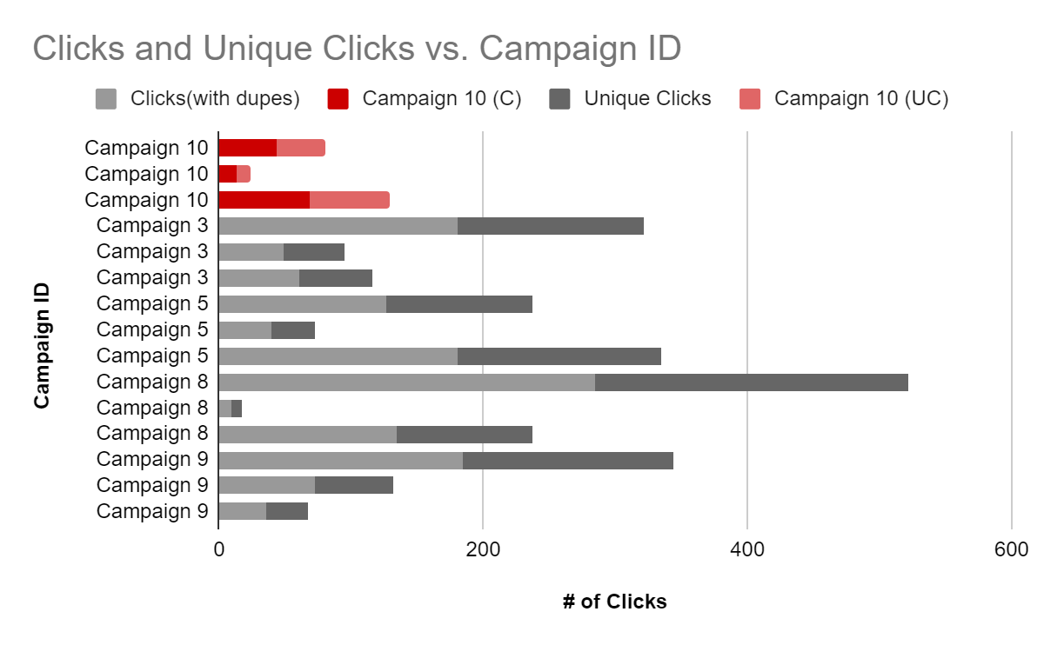Campaign 10 has the consistently lowest rate of unique clicks, and does not waver between success and failure like Campaign 8 has. It shows small levels of improvement, which, combined with its already existing low number of clicks, shows that it will likely not improve at all in any future trials. 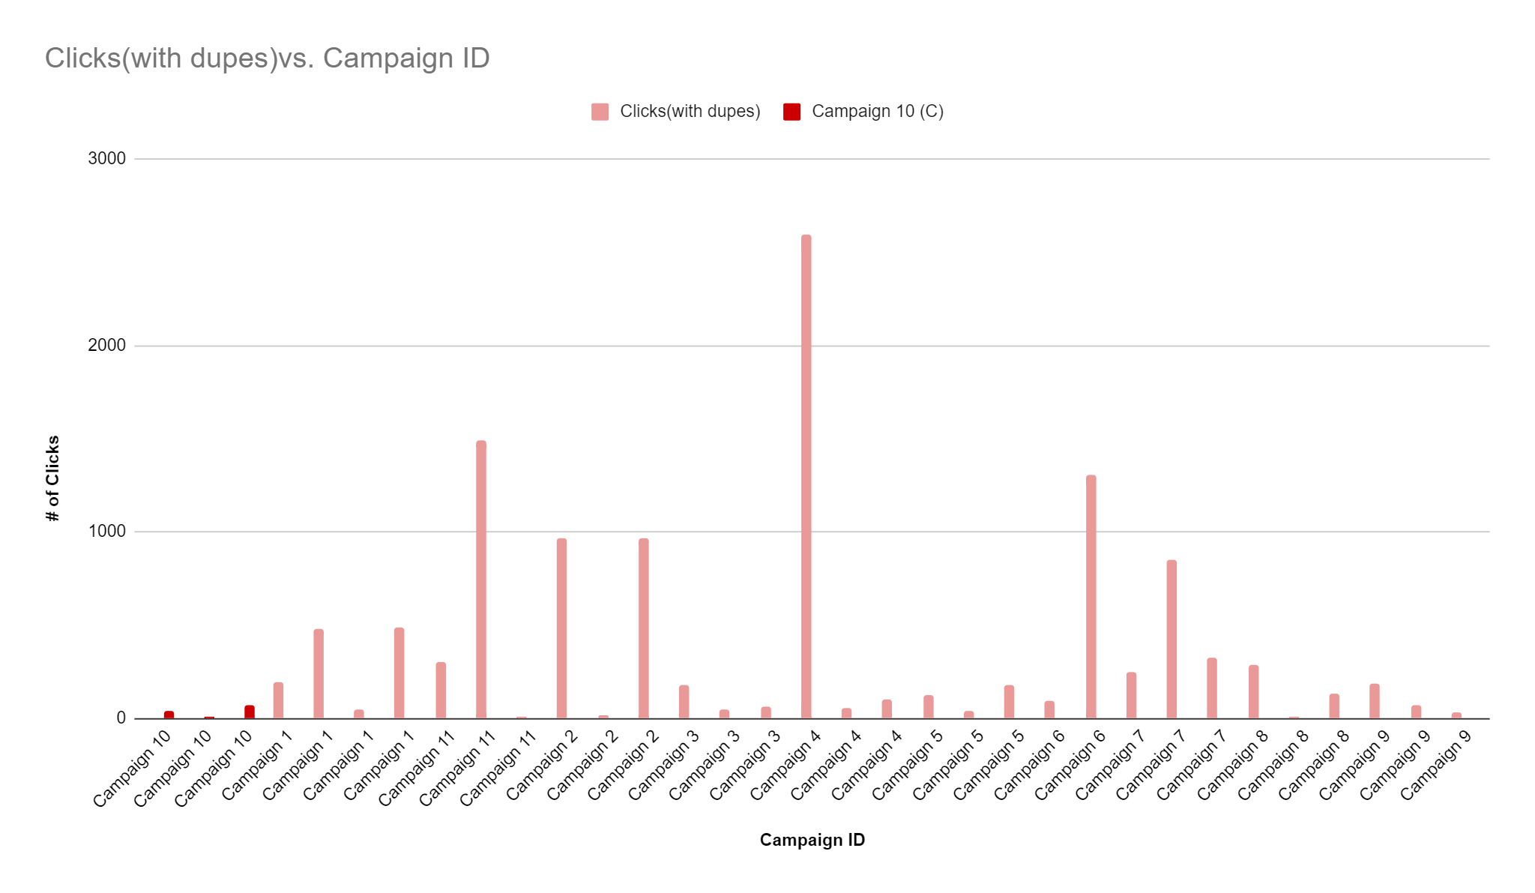

Campaign 10 had one of the least amount of clicks for each of their campaigns than any other campaign. It had no outlier, unlike other campaigns.

**Project Team Details**

Team Lead : Mihir Panchal

Project Lead : Natalia Bartela

Project Manager : Kyle Michael Pingue

Project Manager : Lily Watson

Project Scribe : Noor Tantawy

Project Scribe : Gunnika Singh

Project Scribe : Suraj Swamy